**Step One:**

Installing the GIT plug-in in **Zend Studio** (you only do this once)

**Zend Studio** has a GIT plug-in. In addition to being able to understand your local GIT repository you will create later, it also gives you ‘visual cues’ of what files have been changed but not yet committed. This is very handy!

To install the plug-in, go to the ‘Help’ menu and select ‘Welcome’:

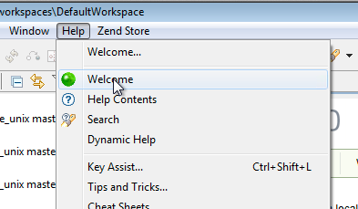

Depending on your version of **Zend Studio**, you will find the GIT plug-in in once of two places

Older versions of **Zend Studio** show it in the ‘Source Control’ section:

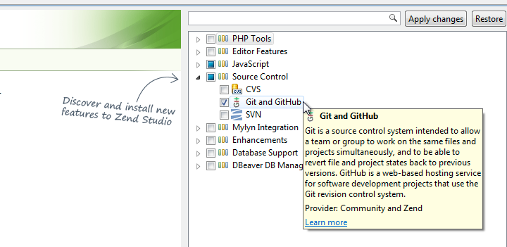

Newer versions of **Zend Studio** show it in the ‘MyIyn Integration’ section:

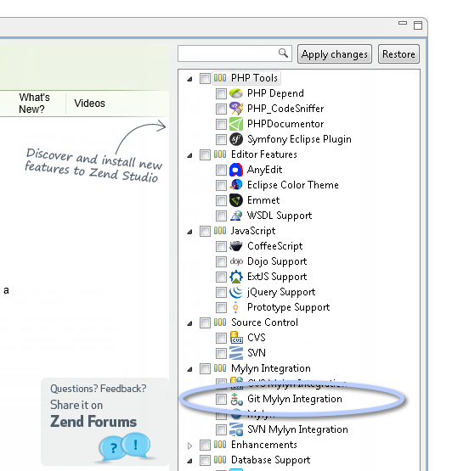

Check the GIT plug-in box and press ‘Apply Changes’.

This completes step one.